Closeout Report
Director’s Review
of the HL-LHC ATLAS Project

May 19-21, 2026

This page intentionally left blank

1.0 Table of Contents

1.0 Table of Contents 3
2.0 Charge Questions: Assignments and Responses 5
3.0 SC1 – Pixels Systems 6
4.0 SC2 – Strips Systems 7
5.0 SC3 – Global Mechanics 8
6.0 SC4 – LAr and DAQ 9
7.0 SC5 – Cost and Schedule 10
8.0 SC6 – Management and ESHQ 11
Appendix A – Charge 12
Appendix B - Review Committee 13

This page intentionally left blank

2.0 Charge Questions: Assignments and Responses
Question #1 (SC1-SC2-SC3-SC4)
Is the project making adequate technical progress to ensure that the completed project will perform as planned and the key performance parameters will be met?

Question #2 (SC1-SC2-SC3-SC4-SC5-SC6)
Is the schedule of the project assuring delivery of US-built components as required by current international ATLAS and CERN schedules?
Question #3 (SC1-SC2-SC3-SC4-SC5)
Are the resource-loaded schedule and the estimate-to-complete up-to-date, accurate, and credible?

Question #4 (SC1-SC2-SC4-SC5-SC6)
Does the project have adequate contingency to successfully deliver to international ATLAS collaboration its threshold and/or objective scope?

Question #5 (SC1-SC2-SC3-SC4-SC6)
Does the project understand its dependence on outside resources such as international collaborators, funding from other agencies, and participation by researchers with other funding sources?

Question #6 (SC1-SC2-SC3-SC4-SC6)
Has the risk analysis been updated to reflect the risk of completing the project and relevant experience with components in production?

Question #7 (SC6)
Is Environmental Safety and Health being handled appropriately?

Question #8 (SC1-SC2-SC3-SC4-SC5-SC6)
Has the project satisfactorily responded to the recommendations from previous reviews?

Question #9 (SC1-SC2-SC3-SC4-SC5-SC6)
Are there any other significant issues that require management attention?

3.0 SC1 – Pixels Systems
Subcommittee: *Matt Jones (Purdue), Karl Ecklund (Rice)

Charge Questions
Question #1
Is the project making adequate technical progress to ensure that the completed project will perform as planned and the key performance parameters will be met?

Yes. The committee was again encouraged by the significant technical progress shown over the past year and we do not anticipate any problems with the project execution that will negatively impact key performance parameters.

Question #2
Is the schedule of the project assuring delivery of US-built components as required by current international ATLAS and CERN schedules?
Yes for TKPP; no for the full scope when taking MC risk assessment into consideration, where there is negative float of ~80 days at 90% C.L.
Question #3
Are the resource-loaded schedule and the estimate-to-complete up-to-date, accurate, and credible?

Yes. The resource-loaded schedule has been updated to account for technical developments and vendor deliverables that have evolved over the past year. The changes to the schedule provide a credible approach to incorporate these developments into the project plan.

Question #4
Does the project have adequate contingency to successfully deliver to international ATLAS collaboration its threshold and/or objective scope?

Yes. Contingency is held at a higher level, however, the risks and potential call on contingency are in the risk register and are considered in the risk Monte Carlo.

Question #5
Does the project understand its dependence on outside resources such as international collaborators, funding from other agencies, and participation by researchers with other funding sources?

Yes.

Question #6
Has the risk analysis been updated to reflect the risk of completing the project and relevant experience with components in production?
Yes.

Question #8
Has the project satisfactorily responded to the recommendations from previous reviews?

Yes. There was a recommendation on addressing sufficiency of labor for production, including contributed labor. The project has considered staffing needs for production and adjusted accordingly.

Question #9
Are there any other significant issues that require management attention?
No

Findings

The team is congratulated for very significant progress made across the pixel WBS since the last review. All components have passed ATLAS PRRs and have proceeded to production readiness.
The design of local support required a change to use stainless steel capillaries for the CO2 cooling as titanium showed unacceptable fluctuations in the pressure drop. A fitting to join the stainless steel capillaries to the titanium evaporators was developed and is in manufacturing now. Materials are all in hand for the co-cured carbon foam and fiber cores, and 30% (50%) of the R0/1 (R1) have been produced.
The module assembly and testing workflow is being exercised and demonstrates the needed throughput of 24 modules / week, matching the planned maximum rate and exceeding the assumed rate of 72/mo in the RLS. This includes parylene coating as well as testing at the three testing sites. Redistribution of L1 module production within the international project increased the number of modules to be built in the US by about 10% and at this time 268 quad modules have been glued and wire bonded, out of planned assembly starts of 1223 (22%).
Initially high losses (17%) from parylene coating and handling have been understood, with changes projecting an acceptable mechanical yield (7–10%). Yield from electrical testing is also lower than the desired 80%. A large contribution to the loss comes from mechanical damage to read out ASICs during sensor-chip hybridization. Some modules with damaged chips can be operated by disabling the affected “core column,” and currently the acceptance criteria allows up to two disabled core columns; this removes up to 5% of the pixels. The issue has been addressed to the extent possible with the hybridization vendors, and future parts are expected to have better yield. A second issue with lost readout during threshold scans affects 10-15% of modules. This is also associated with core columns and QC procedures adjusted to catch these problems. Decisions on module acceptance are made with ATLAS globally. Reduction of module quality can be mitigated by placement in less critical regions of the detector and potentially by building more modules to compensate for lower yields.

Comments

The team is congratulated for very significant progress made across the pixel WBS since the last review. All components have passed ATLAS PRRs and have proceeded to production readiness.
The module assembly workflow has been exercised for 268 modules. However, yield from initial assemblies is lower than desired. Some of this is expected from learning curve effects on initial batches. The core column problems are a concern. Continue to watch this closely and work with ATLAS to make the best use of parts arriving from vendors.
The project has now demonstrated readiness to assemble, parylene coat and test quad modules at the planned production rate of 72 modules/month. Loading and integration tooling and testing is also production ready to receive and integrate modules. The project is in a good position to enter the production phase.
Module assembly and module loading is limited by deliveries from external partners. Working with international ATLAS to secure bare module delivery for quad module assembly and triplet module deliveries for loading and integration would alleviate schedule pressures and reduce standing army labor costs.
Loss of objective scope for the pixel system impacts tracking at high eta (3–4) and jeopardizes high-impact physics goals for the HL-LHC, in particular Vector Boson Fusion and Vector Boson Scattering measurements that address P5 science drivers.

Recommendations

- Over the next 7 months, work with international ATLAS management to reduce the risk of further delays in module delivery from external partners
- Over the next 6 months, review and recommend adjustments to staffing plans that will minimize the impact of standing army costs in the event that module delivery is delayed beyond previous assumptions.

4.0 SC2 – Strips Systems
Subcommittee: *Fabio Ravera (FNAL), Nicola Bacchetta (FNAL)

Charge Questions
Question #1
Is the project making adequate technical progress to ensure that the completed project will perform as planned and the key performance parameters will be met? Yes

Question #2
Is the schedule of the project assuring delivery of US-built components as required by current international ATLAS and CERN schedules? Yes, however, the schedule is very tight, although accelerations are possible, they have not yet been proven
Question #3
Are the resource-loaded schedule and the estimate-to-complete up-to-date, accurate, and credible? Yes

Question #4
Does the project have adequate contingency to successfully deliver to international ATLAS collaboration its threshold and/or objective scope? Yes

Question #5
Does the project understand its dependence on outside resources such as international collaborators, funding from other agencies, and participation by researchers with other funding sources? Yes

Question #6
Has the risk analysis been updated to reflect the risk of completing the project and relevant experience with components in production? Yes

Question #8
Has the project satisfactorily responded to the recommendations from previous reviews? Yes

Question #9
Are there any other significant issues that require management attention? No

Finding

Comments

The review committee thanks the review team for the well-prepared presentations and for the candid and open discussion of the issues currently facing the Strips project. In particular, the team is to be commended for its impressive response to the significant sensor cracking and bPOL12 challenges that have arisen and been addressed since the previous review.

The review committee acknowledges the challenges associated with the current schedule, which indicates 1.8 months of negative float increasing to 7.5 months at the 90% confidence level. Three mitigating actions have been proposed to recover the required float:
- Eliminate the gap and ramp-up period between SS and LS stave production (projected gain: 1.5 months)
- Increase the stave production rate from 1.5 to 1.75 staves per week (projected gain: 3.5 months)
- Exchange 24 US cores for 24 UK loaded staves (projected gain: 3 months)
The committee recommends that actions 1 and 2 be implemented as soon as possible and adopted as the new baseline schedule. Regarding action 3, the committee understands that the project has approximately six months to determine whether to proceed with the exchange and to define the appropriate balance between cores and loaded staves to be exchanged with the UK.

The committee further suggests evaluating the feasibility of off-hour work (e.g., weekends) to provide additional schedule contingency, should further acceleration become necessary.

The committee acknowledges the potential to accelerate module production by 20% and strongly encourages the project to pursue this opportunity. Advancing module production would enable earlier completion of this phase, allowing stave production to proceed without interruption and potentially resulting in cost savings.

The committee encourages the project to critically reassess the remaining risks and to retire them as promptly as possible, thereby improving the reliability of the Monte Carlo projections used to estimate the remaining schedule float.

The committee understands that a critical decision was made in early 2026 to resume production with bPOL12 v6, incorporating a modification to the enable logic. The committee recognizes the extensive testing that supported this decision and notes that the team continues to closely monitor ongoing bPOL12 investigations and any newly emerging issues. It is important that the decision-making process and all associated testing be thoroughly documented to demonstrate that no further impacts on stave performance or operation are expected. Furthermore, the project is leaving open the option to transition to the new FX1 bPOL12 version for the innermost layers. The committee agrees that this option should remain under consideration, consistent with the evolution of hybrid and module production.

Recommendations
- Proceed to implement as the new baseline the following options to accelerate stave production:
  - before the end of August 2026, remove the gap and ramp up between the SS and LS stave production
  - before the end of October 2026, increase stave production rate from 1.5 to 1.75 staves per week .
- Before the end of October 2026, proceed to implement the proposed 20% increase in module production rate as the new baseline for the schedule

5.0 SC3 – Global Mechanics
Subcommittee: *Andreas Jung (Purdue)

Charge Questions
Question #1
Is the project making adequate technical progress to ensure that the completed project will perform as planned and the key performance parameters will be met?

Yes.

Question #2
Is the schedule of the project assuring delivery of US-built components as required by current international ATLAS and CERN schedules?
Yes.
Question #3
Are the resource-loaded schedule and the estimate-to-complete up-to-date, accurate, and credible?

Yes.

Question #5
Does the project understand its dependence on outside resources such as international collaborators, funding from other agencies, and participation by researchers with other funding sources?

Yes.

Question #6
Has the risk analysis been updated to reflect the risk of completing the project and relevant experience with components in production?

Yes, risks have been retired to the extent possible and the only remaining risks are associated with “damage during transport”.

Question #8
Has the project satisfactorily responded to the recommendations from previous reviews?

Yes.

Question #9
Are there any other significant issues that require management attention?

Yes, see comments.

Findings

The Committee reviewed Global Mechanics with the following subprojects:

- WBS 6.3.1 - Integration System Testing
- WBS 6.3.2 - Outer Cylinder
- WBS 6.3.3 - Pixel Support Tube
- WBS 6.3.4 - Structural Bulkhead
- WBS 6.3.5 - Strip Shells
- WBS 6.3.6 - Infrastructure
- WBS 6.3.7 - Internal Support Tubes.

The Committee reviewed Global Mechanics with emphasis on WBS 6.3.1 (Integration System Testing), WBS 6.3.7 (Internal Support Tube / Inner Pixel Tube), and aspects associated with future Integration & Installation activities.

The majority of sub-projects (WBS 6.3.1, 6.3.2, 6.3.4, 6.3.5, 6.3.6) are completed. The large outer cylinder structure has been delivered to CERN and assembly for the same completed at SR1.

WBS 6.3.1 – Integration System Testing / Installation Activities
The Committee notes that WBS 6.3.1 is complete except for LoE (L2 management) from the standpoint of the presently defined scope; however, discussion identified a number of future installation-related deliverables that remain relevant for later project phases. Examples discussed include specialized installation tooling and support structures required for detector integration and insertion activities, such as platforms, lifting systems, and other dedicated installation equipment.

The Committee understands that several of these activities and deliverables may remain relevant as the project transitions through later phases of integration and installation past the closure of the global mechanics WBS. Given the extended timescale associated with these activities, clarification of ownership and funding responsibility for installation-related deliverables would be beneficial.

WBS 6.3.3 – Pixel Support Tube (PST) and Layer 1 (L1) Subsystem
The Pixel Support Tube (PST) and Layer 1 (L1) subsystem consists of four composite cylindrical shells with integrated hat stiffeners. Three shells form the barrel structure, while two forward shells support Layer 0 (L0). The larger diameter shell corresponds to L1 and includes rails to facilitate the insertion of the PST.

Barrel mandrel tooling for the PST was completed at the time of the 2025 review; however, due to prepreg material availability, production shifted to later in 2025 – it is completed by now and satisfies tolerances. Metrology measurements at the current location (Oxford University) is taking place right now.

Rail tooling for the PST was scheduled for fabrication in summer 2025 and is done by now with the bonding of rails an open remaining task in WBS 6.3.3 - closeout for WBS 6.3.3 is still expected within the current fiscal year.

A moderate increase in material cost was incurred due to ordering 120% of the baseline estimate for prepreg material. This decision was taken to mitigate the risk of material shortages during production. Both Cost Performance Index (CPI) and the Schedule Performance Index (SPI) is improving as recent and last deliverables are completed.

WBS 6.3.7 – Internal Support Tubes (IPT/IST & flanges)
Assembly tooling for the IPT barrel is complete and ready for production. The Committee reviewed the status of the Inner Support Tube (IST) and Internal Pixel Tube (IPT) structures, including discussion of the expected structural deflection and available design envelope. During this review it became clear that an earlier interpretation (2025 findings) of the structural margin had been based on a misunderstanding of the available clearance. While an IPT deflection of approximately 700 μm had initially been discussed relative to a perceived envelope of approximately 650 μm, clarification showed that the actual available envelope is approximately 2 mm, with no nearby structures or objects within even approximately 3 mm of the relevant region. Based on this clarification, the Committee does not identify a concern regarding available mechanical clearance or interference risk.

The Committee also discussed long-term considerations associated with tooling and replacement scenarios for the IPT. It was noted that a future replacement of inner detector components during the HL-LHC phase couple years into ATLAS operation, may require extraction procedures that do not preserve the original IPT structure in an intact state. As a consequence, the ability to reproduce tooling, interfaces, tolerances, manufacturing approaches, and assembly procedures over extended timescales becomes increasingly important. Particular emphasis was placed on preservation of CAD models, manufacturing information, tooling definitions, assembly procedures, metrology information, and other relevant project documentation needed to support future replacement activities.

Comments

The global mechanics project has achieved a 99% completion level and the committee congratulates on successful delivery of components to CERN. The only work remaining in WBS 6.3.3 is bonding of support rails and in 6.3.7 the bonding of sub-parts of IST being bonded at CERN into the full length IPT/IST. Flanges for IPT/IST are currently being done and expected to be done this year. A float of 350 days remains to finish the last deliverables in global mechanics.

The Committee notes near completion of the Global Mechanics effort and observes improvement relative to findings discussed in the prior review cycle. In particular, clarification of the IPT deflection and available mechanical envelope resolved what initially appeared to be a potential concern and demonstrated that adequate design margin exists.

The Committee recognizes that, as the project transitions from production toward Integration & Installation, long-term preservation of project knowledge and infrastructure becomes increasingly important. While tooling and deliverables required for near-term activities appear well managed, maintaining sufficient information and documentation for future interventions extending beyond the initial installation phase may require additional attention.
The Committee notes that future maintenance, or detector intervention activities may occur under conditions different from the original construction and installation phase, particularly in detector regions that may become activated during operation and where access or handling constraints could differ substantially. Preserving engineering documentation and institutional knowledge, including tooling information, CAD models, manufacturing and installation procedures, metrology information, and lessons learned, would provide long-term benefit by maintaining reproducibility of detector elements, interfaces, and installation procedures.

Recommendations

Recommendation 1: The committee recommends, within a year, to preserve global mechanics tooling, manufacturing information, and definitions as needed, as well as CAD models, lessons learned, and associated documentation to ensure reproducibility for potential future interventions.

6.0 SC4 – LAr and DAQ
Subcommittee: *Darin Acosta (Rice), Paul Rubinov (FNAL)

Charge Questions
Question #1
Is the project making adequate technical progress to ensure that the completed project will perform as planned and the key performance parameters will be met?

Yes for both LAr and DAQ

Question #2
Is the schedule of the project assuring delivery of US-built components as required by current international ATLAS and CERN schedules?
Yes for both LAr and DAQ, but FEB2 QC testing is on the critical path for LAr deliverables and should be prioritized by the project

Question #3
Are the resource-loaded schedule and the estimate-to-complete up-to-date, accurate, and credible?
Yes for both LAr and DAQ with the caveat that we did not have the time to drill down on the resource loaded schedule.

Question #4
Does the project have adequate contingency to successfully deliver to international ATLAS collaboration its threshold and/or objective scope?

Yes, both LAr and DAQ are on an excellent trajectory to complete the objective scope but control of the contingency and other resources is outside the scope of the Level 3

Question #5
Does the project understand its dependence on outside resources such as international collaborators, funding from other agencies, and participation by researchers with other funding sources?

Yes for both LAr and DAQ

Question #6
Has the risk analysis been updated to reflect the risk of completing the project and relevant experience with components in production?

For the most part, yes, but one part of the risk register appears out of date: RD-06-04-04-001 (Front end boards delivery schedule slippage, or discovery of missed target specifications)

Question #8
Has the project satisfactorily responded to the recommendations from previous reviews?

Yes for both LAr and DAQ

Question #9
Are there any other significant issues that require management attention?
No for both LAr and DAQ

Findings

- For LAr, we are impressed with the excellent integration and coordination of the NSF and DOE scope management.
- For DAQ, we commend the team on having final prototypes that meet specifications and nearing readiness for preproduction, and for nearing completion of the firmware tasks of WBS 6.7.4.
- For WBS 6.4.4 on production system integration, BNL has set up a FE crate mockup for integration tests of the electronics in realistic conditions as well as the FEB2 QC test stand.
- The Objective KPPs for WBS 6.4.4 comprise the FEB2 production QC testing, where installation is on the LAr project critical path, and a full chain system integration test of the LAr and TDAQ electronics. Significant progress has been made on this.
- For WBS 6.4.5 a Production Readiness Review of the LAr Preamp/Shaper ASIC took place in Sept. 2025 and was successfully passed. All Preamp/Shaper ASICs have been produced and packaged.
- An automated ASIC testing system was set up at BNL for WBS 6.4.5, and over 27k chips were tested between Nov. 2025 and May 2026 with a yield rate of 95.7%. The robotic system subsequently broke, and a couple week delay was introduced waiting for parts from France. Upon recovery, the yield rate has dipped somewhat.
- For WBS 6.7.3 (Felix), the latest prototype, FLX-155A, is fully functional. There are minor issues with slow control and power circuitry, and those issues will be fixed in the pre-production boards. The design has adequate headroom in links and FPGA resources for all variations needed by the subsystems, and operating temperatures are acceptable.
- For WBS 6.7.3 (Felix), the team developed a Built-in self-test for QA/QC to be used by the vendor and at CERN.
- WBS 6.7.4.1 (EF Tracking Data) is complete. The pixel decompression and clusterization firmware for the FPGA-based tracking option was completed and presented at the ATLAS technology choice review, where the final outcome was to go with a GPU-based solution.
- WBS 6.7.4.2 (Global Trigger firmware for transmission to Felix) has been tested with the latest GCM and Felix prototypes. The whole readout chain is functional, and trigger link latency tests are in progress.
- For WBS 6.7.1, the GCM v4 prototype has been designed, produced, and is now under test. Compared to the v3 prototype, one of the two FPGAs was switched to the one also used by Felix in order to get around a severe data link latency issue on the critical path for trigger. An issue with noise bursts from the Samtec Firefly links has been resolved with a recent firmware update by Samtec.
- The FDR for GCM is scheduled for July 2026, and and PRR for April 2027
- The OKPP for WBS 6.7.7 (procurements through CERN) entails the full cost of the US ATLAS commitment of the GCM and Felix board productions, and the TKPP is 55% of the OKPP commitment. For WBS 6.7.1 and 6.7.3 the OKPP includes acceptance testing.

Comments

For the LAr and DAQ projects, we are impressed with the excellent integration and coordination of the NSF and DOE scope management and excellent technical progress.
We commend the teams on completing the LAr preamp/shaper chip design and production, and having final DAQ prototypes that meet specifications and nearing readiness for preproduction, and for nearing completion of the firmware tasks of WBS 6.7.4.
The project should ensure sufficient spare parts for the QC test stands used for production testing.
The Objective scope of the LAr FEB2 QC testing and integration should be considered critical to enact for the project and international ATLAS, since the cards will be installed on the detector in the collision hall with much less accessibility.
On the DAQ project, WBS 6.7.3 (Felix) has the shortest float of 105 days, driven by waiting for an ATLAS Production Readiness Review in November 2026. Successful pressure by the Project on international ATLAS to move that review earlier could recover additional float.
Recommendations

None for both LAr and DAQ

7.0 SC5 – Cost and Schedule
Subcommittee: *Liz Light (ORNL), Lorri Stapleton (FNAL)

Charge Questions
Question #2
Is the schedule of the project assuring delivery of US-built components as required by current international ATLAS and CERN schedules? Yes for TKPP across all WBSs. No for WBS 6.02 Strips for OKPP. See Comments.
Question #3
Are the resource-loaded schedule and the estimate-to-complete up-to-date, accurate, and credible? Yes

Question #4
Does the project have adequate contingency to successfully deliver to international ATLAS collaboration its threshold and/or objective scope? Yes, see comments

Question #8
Has the project satisfactorily responded to the recommendations from previous reviews? Yes

Question #9
Are there any other significant issues that require management attention? No

Findings

DOE TPC is $200M with an ETC of $43.2M

TPC is 63% Labor, 35% Materials, 2% Travel

Contingency on the ETC is 13.3M or 31% of To Go costs. Monte Carlo simulations at a 90% Confidence Level show a contingency need of $20.8M for the full scope, elevating the estimated TPC to $206.7M. 90%CL on TKPP only estimates a need for $16.7M contingency with a TPC of $196.4M. Note that at a 70%CL, the estimated cost for the full scope (TKPP + OKPP) is within the $200M TPC.

The EAC has increased from $162M as of the January 2023 baseline to $187M as of March 2026. The cost difference is mainly attributed to WBS 6.02 Strips and WBS 6.01 Pixels.

Through FY26 $195M in DOE Funds have been received with an additional $5M anticipated in FY27, completing the distribution of funds from DOE.

8 separate subprojects are maintained in P6. DOE and NSF scope are both tracked in the schedules but are uncoupled at WBS L2 except for WBS 6.04 LAr and WBS 6.07 DAQ which break at L3.

WBS 11 I&I was de-scoped from the US-ATLAS project and will be part of Operations beginning 10/1/2026. The remaining I&I funds of $6.04M were returned to contingency.

Schedule quality for the baseline and working schedules was very good. Expectations and practices were clearly articulated and verifiably consistent across all WBSs.

The project demonstrated ongoing review of material escalation and 3% seems to fit the needs of the project. CERN has established fixed priced contracts that the project is able to take advantage of to limit escalation impacts

This review focused on status through March 2026.

The March 2026 BAC is $175.7M, EAC is $186.7M, SPI is 0.92 (relatively constant) and CPI is 0.93 (trending downward).

The EVMS scorecard of March 2026 status:
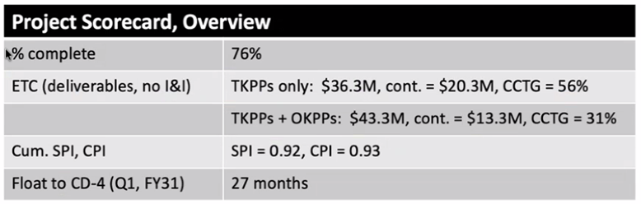

Schedule float for OKPP deliverables by Technical WBS:
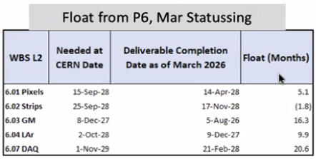

Monte Carlo Schedule Risk Analysis Results
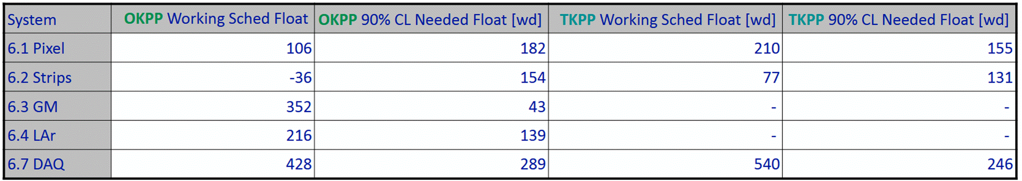

CD Milestone status:
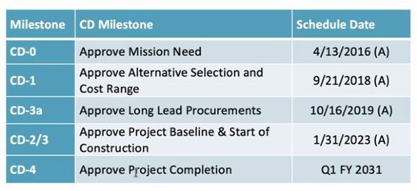

The current cost to complete the OKPPs and decision dates to decide to proceed are shown in the chart below:

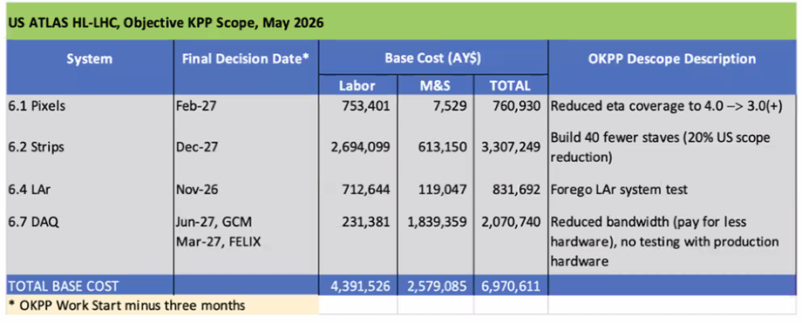

Comments

- The project has benefited from early DOE funding which has enabled the schedule to be technically driven rather than resource limited.

- CAM interviews were conducted to investigate cost variance concerns. CAMs had a very clear understanding of the circumstances and events that precipitated variances as well as necessary actions to recover both cost and schedule. We appreciate the candor and transparency demonstrated by the CAMs as well as the full project team on this review.

- The project is committed to delivering the full project scope. Completion of the TKPPs is the highest priority for the use of on-project funds. The DOE has stated its commitment to deliver both TKPPs as well as OKPPs to ATLAS and CERN. The project should continue to work with ATLAS Management, DOE and other stakeholders to realize the full scope of US ATLAS.

- The project has done a nice job of mitigating optimism within the risk recording and analysis, but the 90% CL will need to be monitored closely to evaluate OKPP scope completion. The project should consider a more frequent review of Monte Carlo simulations (after risk workshops/register updates) to better anticipate contingency and TPC outcomes.

- The current plan estimates that WBS 6.02 - Strips will not meet current CERN need dates for OKPP by 1.8 months due to design issues (cold noise, fracturing) and external dependencies (bPOL chips and substrate availability). Planned mitigation strategies could save an estimated 7 months duration and should be monitored closely at the project level following implementation to ensure efficacy.

Recommendations
- The project should enact the proposed acceleration measures for the WBS 6.02 Strips production before the end of October 2026.

8.0 SC6 – Management and ESHQ
Subcommittee: *Steve Nahn (FNAL), Giorgio Apollinari (FNAL and Review Chair)

ESHQ
Charge Questions
Question #7
Is Environmental Safety and Health being handled appropriately?
Yes
Findings

The project updated the ISM, HAR, Construction Safety and Health Plan, and Security Vulnerability Analysis within the last year
There was one ergonomic recordable injury at a participating institute where tweezers work in full PPE caused repetitive stress discomfort, and no ergonomic assessment had been done. Proper actions were taken. The Project TRC rate is 0.21 and DART rate 0.
There is a solid framework for QA that is applied across the project and the transition to a new QA associate at Brookhaven appears to have been seamless.

Comments

While the Quality Control plans in the project documentation were valid at the time of CD-2, in some cases the QC plan which both the domestic and international collaborators actually use in practice has evolved with the experience with pre-production and early production. It would be prudent to refresh the project documentation to reflect these changes.

Recommendations

- None

Management

Charge Questions
Question #1
Is the project making adequate technical progress to ensure that the completed project will perform as planned and the key performance parameters will be met?

Yes. Technical progress is satisfactory. Threshold KPP parameters are achievable and with careful planning the Objective KPPs are also achievable

Question #2
Is the schedule of the project assuring delivery of US-built components as required by current international ATLAS and CERN schedules?
No. Recent technical issues have delayed both the international and domestic Upgrade efforts, yet the current International ATLAS need-by dates have not been adjusted accordingly, leading to a few months of negative float in some areas. The ATLAS and CERN consensus is to concentrate on project acceleration at this point rather than shift the schedule end dates.

Question #4
Does the project have adequate contingency to successfully deliver to international ATLAS collaboration its threshold and/or objective scope?

Yes. Restricting to the Threshold KPPs only, the contingency is more than sufficient. Expanding to include the Objective KPPs, the margin reduces substantially, but with careful management there should be sufficient contingency. See below

Question #5
Does the project understand its dependence on outside resources such as international collaborators, funding from other agencies, and participation by researchers with other funding sources?

Yes.

Question #6
Has the risk analysis been updated to reflect the risk of completing the project and relevant experience with components in production?

Partially Yes - the Risk analysis is updated regularly, but there is potential over-conservatism. See below

Question #8
Has the project satisfactorily responded to the recommendations from previous reviews?

Yes

Question #9
Are there any other significant issues that require management attention?

No

Findings

Overall Technical status - good progress getting into production, despite several new obstacles associated with critical deliverables
The project Transition to Operations plan (docdb 1413) was last updated September 30, 2022.
After removing the Integration and Installation from the scope of the project, the ETC for the Threshold KPP scope is $36.3M, leaving $20.3M as available contingency, a healthy 56%. Including the Objective KPPs moves $7M from available contingency to ETC, resulting in a still viable 31% contingency on the 43.3M ETC.
The needed contingency estimate derives from Industry-standard simulation methods, based on Estimate uncertainty on the remaining tasks and a risk register with 78 active threats and 1 active opportunity, fed into the simulation to derive upper limit on expected contingency and schedule extension at a given confidence level. The task uncertainty distribution, weighted by Budgeted cost, is shown below, for labor and M&S separately
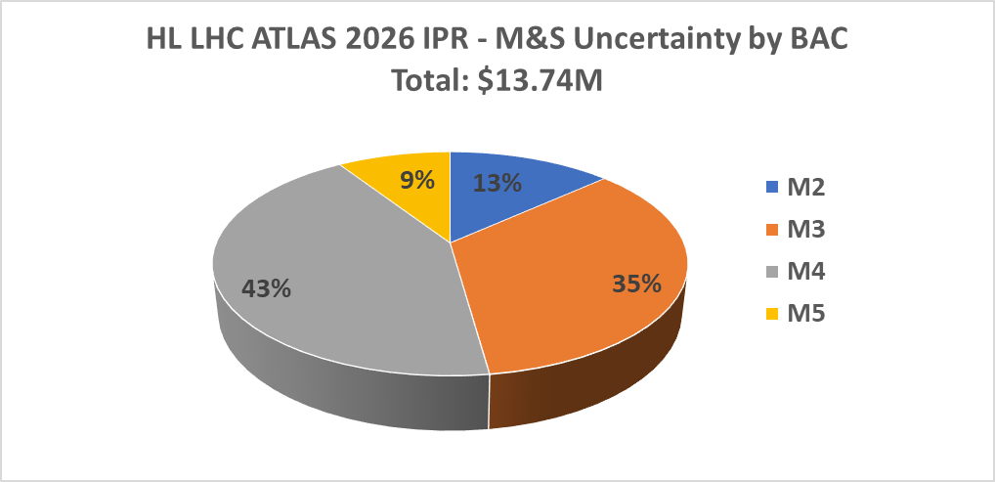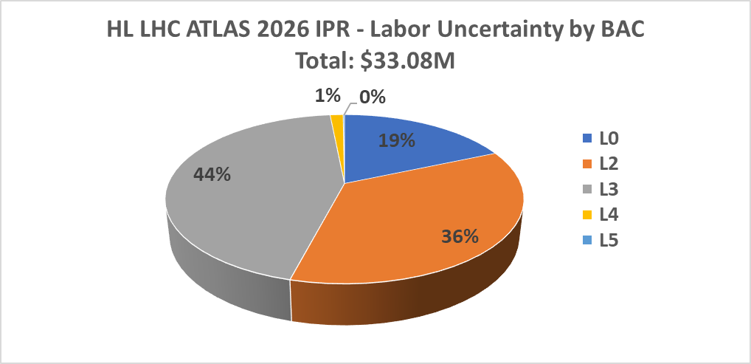
Due to recent events, supply chain risks have been segregated from the rest of the risks. Categorizing by the product of <Average Cost Impact>*Probability the distribution of active and retired risks by subsystem is
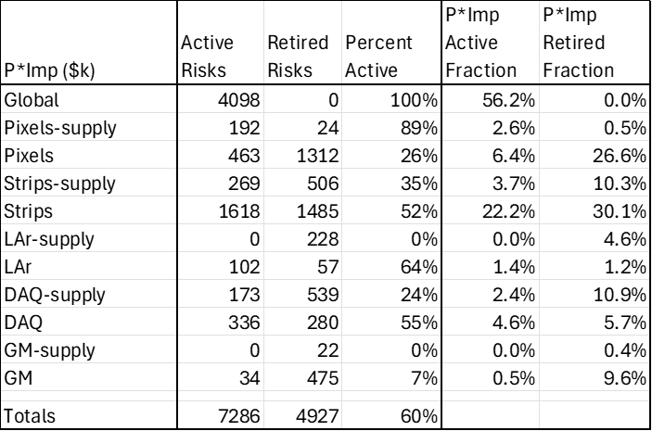
The top ten risks that drive the cost contingency are
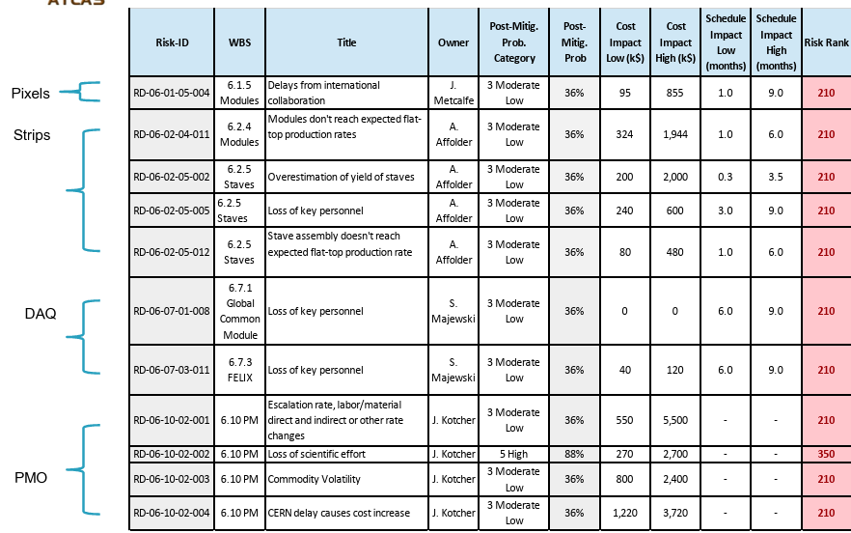
Within the risk register, there are 26 separate risks associated with the “Loss of Key Personnel”, delays are covered both globally and in subsystem registers as well as accounted for in the duration uncertainty modeling, and the largest risk, for loss of scientific effort, assumes 88% probability and a flat distribution between 10% and 50% of the remaining 54 FTE-years of scientific effort will need to be supplanted by technical labor.

Comments

Thanks to the ATLAS Team for the openness and professional presentation on the status of HL-LHC ATLAS, In particular, it is appropriate to call out the Project Manager for competent and decisive leadership of this and previous endeavors in HEP over the last 34 years.
The ATLAS team clearly has full command of all the issues arising as the production phase ensues, and given the funding constraints it is the appropriate time to begin to understand the end game.
The project should adopt and project a stance consistently across the Organization Breakdown Structure that the Objective scope is within reach with the current resources. At this moment there is no evidence to support descoping any Objective scope from the project, and SC6 endorses the pursuit of all of the Objective scope.
The committee supports the prudent decision to move Integration and Installation effort off project, prioritizing construction deliverables.
Given that the Risk analysis is used as an input for scope decisions which can impact the ultimate physics performance or future Operation of the detector, there is a concern that double counting the impact of delays, loss of key personnel or scientific labor, etc may skew the Contingency estimate high (see examples in the Findings). A thorough audit of the risks themselves, the interplay between global and subsystem risks, as well as inclusion of risk opportunities should confirm that the contingency analysis is not overly conservative. A time profile of the future expected contingency reduction would be a useful handle in making decisions on Objective scope.

Recommendations

- Before the next IPR, update the Transition to Operations plan to reflect the recent removal of I&I from the project
- Update the Risk Register with the inclusion of Opportunities as identified at the Review by some of the L2 sub-system presentations, or other opportunities as developed in Risk discussions.
- As scope decision points become more frequent, perform a Risk Register update and subsequent Contingency Analysis on a quarterly basis to provide confidence in the decision.
- In order to ensure the project can realize the full scope of HL LHC ATLAS Detector Upgrade, perform a bottom-up re-evaluation of ETC and Contingency informed by production experience with sufficient latency, of order a month, prior to the first decision on Objective Scope

Bonus Charge Question*
Is the project team properly staffed with individuals that have the required skills to deliver the proposed technical scope within baseline budget and schedule?

Resounding YES. While without question the departure of the PM leaves some BIG SHOES to fill, a great performance is more about the orchestra than the conductor. The ATLAS team is strong and the path is clear so we expect they won’t miss a beat, regardless of the transfer of the baton.

Appendix A – Charge

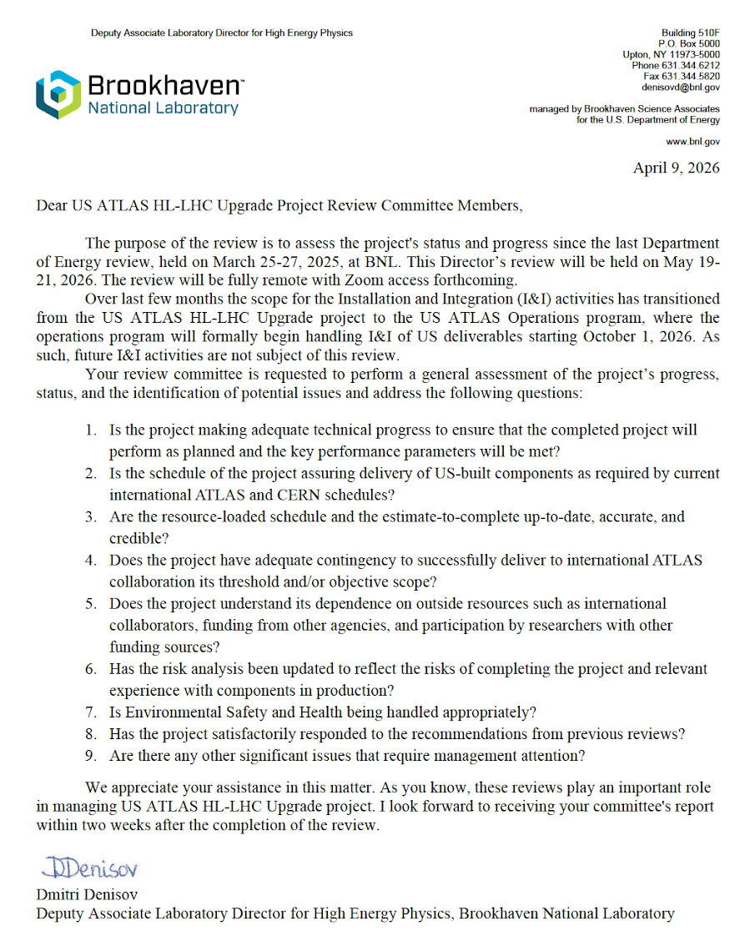

Appendix B - Review Committee



